**QUERY DATABASE SAMPLE**

1. SELECT * FROM `berobat`

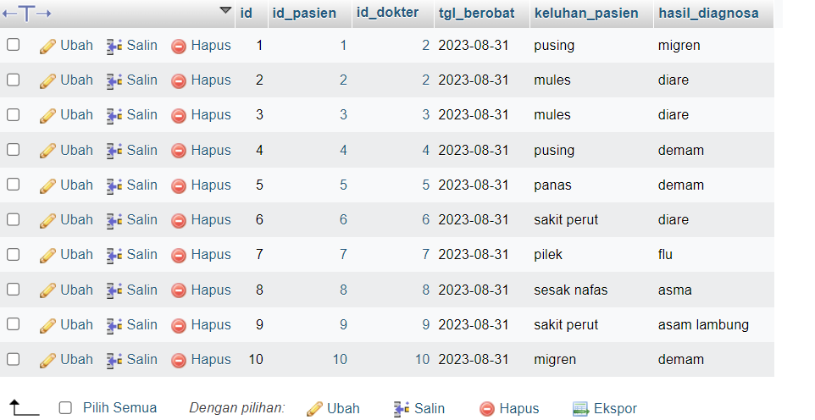

1. SELECT `hasil_diagnosa` FROM `berobat` WHERE 1

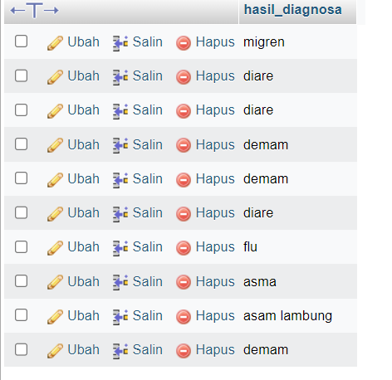

1. SELECT `id_pasien` FROM `berobat` WHERE 1

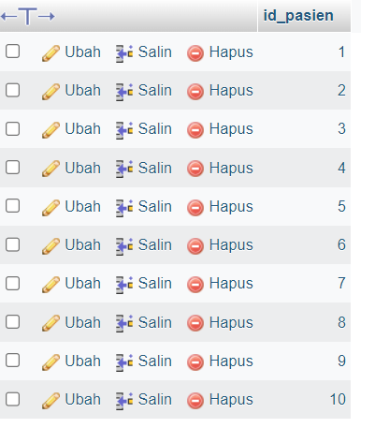

1. SELECT `id` FROM `berobat` WHERE 1

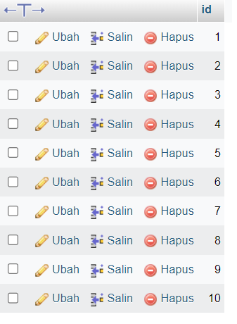

1. SELECT `tgl_berobat` FROM `berobat` WHERE 1

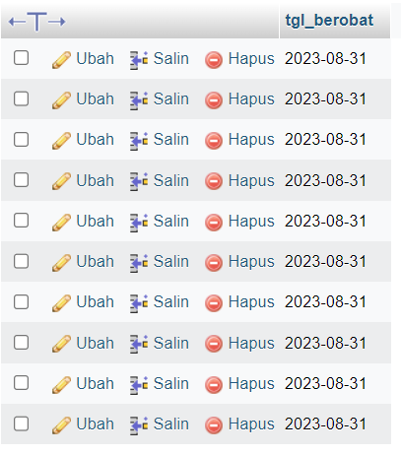

1. SELECT `keluhan_pasien` FROM `berobat` WHERE 1

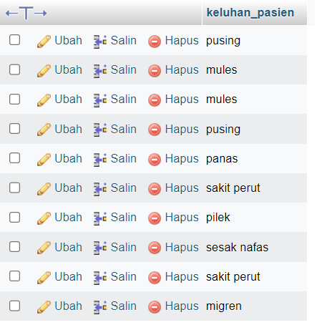

1. SELECT * FROM `pasien` WHERE 1

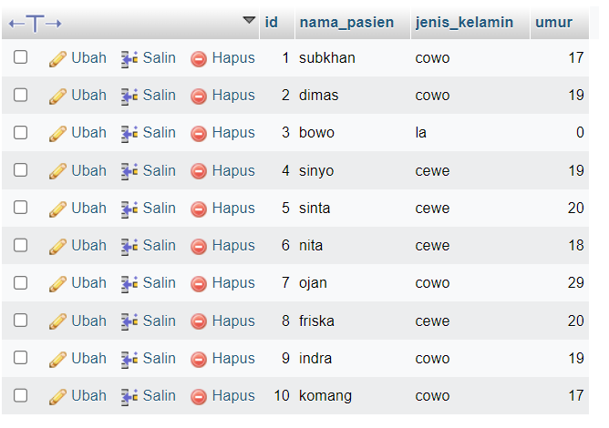

1. SELECT `id` FROM `pasien` WHERE 1

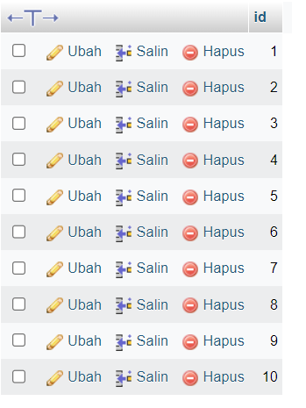

1. SELECT `nama_pasien` FROM `pasien` WHERE 1

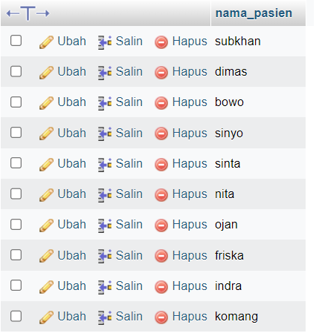

1. SELECT `jenis_kelamin` FROM `pasien` WHERE 1

